Team Building Workshop
Report

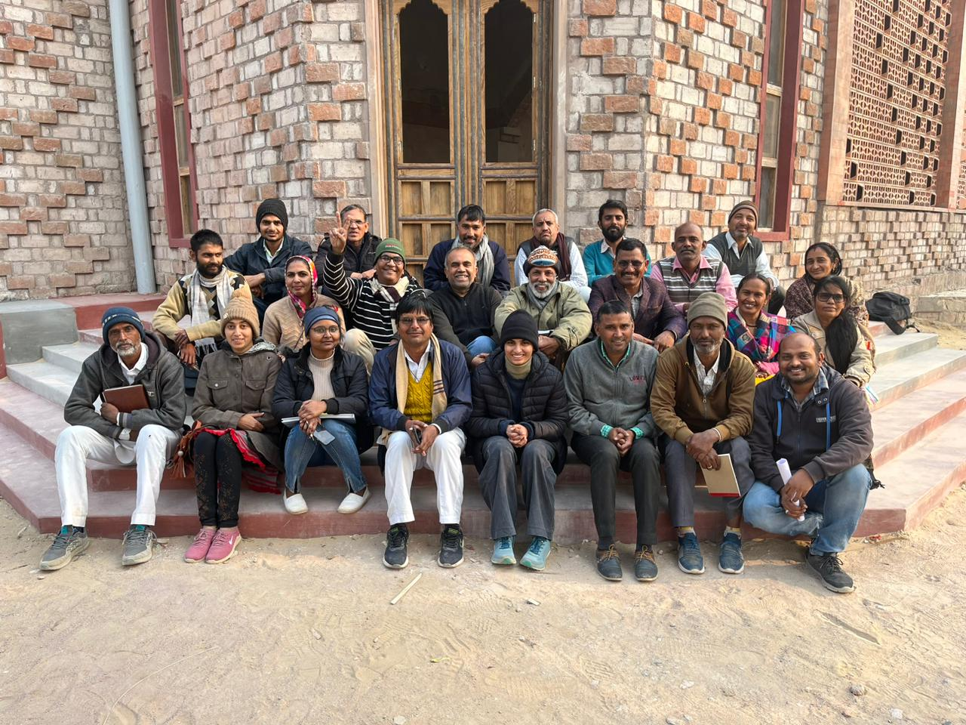

Organised at URMUL Seemant Samiti
Facilitated by Mr. Nilesh Mantri
Date- 21 to 23 January 2023

INDEX

About the workshop………………………………
Day 1 - session 1 …………………………………
Day 1 - session 2(post lunch)……………………
Day 2 - session 3…………………………………
Day 3 - session 4…………………………………
Day 3- session 5………………………………….

ABOUT THE WORKSHOP
A three day workshop on team building which further tried to address the relationship between an individual his /her work and his/her team.
ORGANISERS
URMUL Seemant Samiti
PARTICIPANTS
25 participants from the various departments of URMUL joined the workshop.
OBJECTIVE
To strengthen personal, team and organisation communication and coordination with clarity in work and objectives.
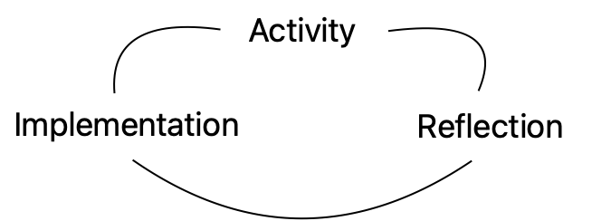
PEDAGOGY
The fundamental division of the session was into two parts- an initial PLAYFUL half followed by a THOUGHTFUL half. It was observed that to remove the feeling of dullness from the thoughtful activities were presented.
Participants were not given any negative inputs or corrected instead activities were followed with conversational reasoning.

DAY 1
21 JANUARY’ 2023
Session 1
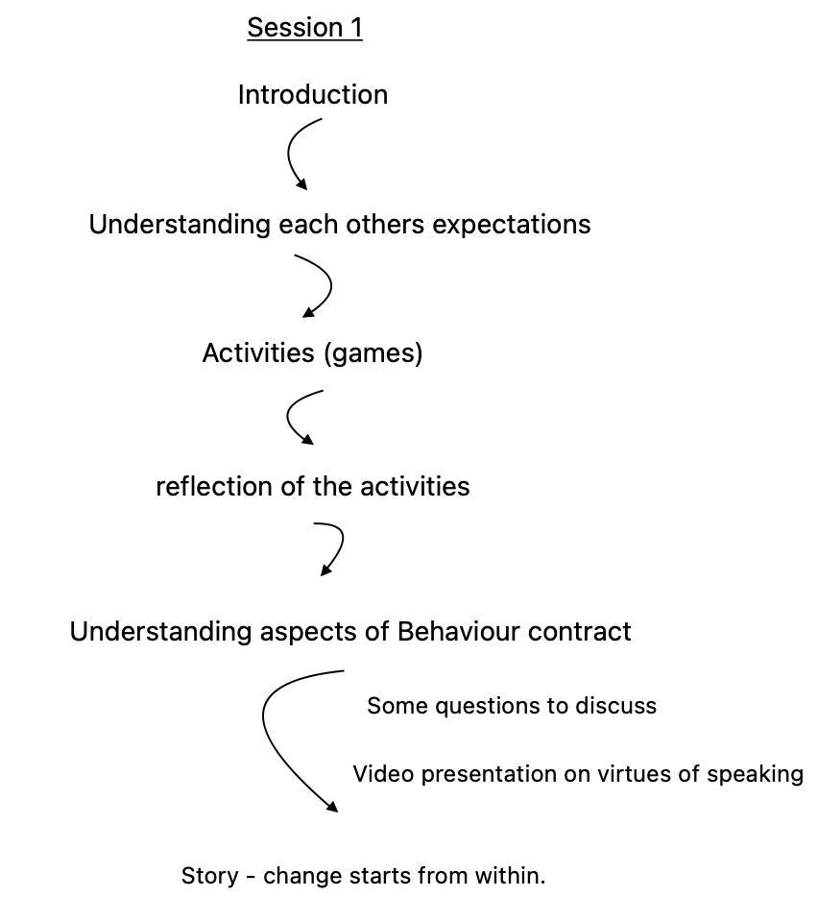

(1) Introduction
The workshop started with introduction of the participants with the reference to their name and area of work followed by the facilitator introducing himself and the programme.
“The workshop would not have anything particularly new for the participants but may include new experiences which would be observed, understood and implemented for the first time or for strengthening.”

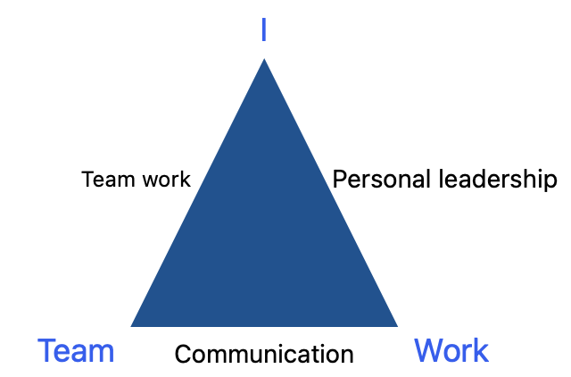

(2) Expectations
Following the introduction expectations from each other were understood.
Expectation of the facilitator for the participants
- Participation
- Punctuality
- Commit to apply the learnings and observations through activities, their reflection and implementing them.
- Parking lot - holding the thought to self which does not cater to the larger interest of the group and clarifying in person with the facilitator.
- Enjoy, have fun.
Expectations of the participants
- Respect towards each other
- Participation
- Compassion
- Understand how to build coordination and have clarity.
- How to have ownership
(3) Activity
Activity 1 -
Participants were asked to form a circle and follow the instructions like move towards right / left / forward / backward / jump.
Activity 2 -
Participants were asked to form a circle and to act opposite of the instruction given.
Activity 3 -
Participants were asked to form a circle ,act opposite of the instruction given but to repeat the instruction given out loud.
- Realising that some were in confusion and were asked to help each other in the game and in our lives having similar dilemmas.
Activity 4 -
Participants were asked to repeat the song and enactment of the facilitator.
Activity 5 -
Participants were asked to hand shake with any individuals giving preference to their comfort rather than to choose three other individuals and touch their arms.
Following completion of the two tasks the participants were to choose three other individuals and join their back and one knee with them then hold each other's thumb.
Reflection
Discussion following the activities
The activities involved behavioural contract between participants implying to make certain behaviour changes within a specified time to achieve the goal.
Findings through reflection of the activities
- Comfort- it was easier to form a behaviour contract with some participation than others.
- Different aspects of relationship

Put down (demotivate) and put up (motivate)
- Mixing forming bonds with each other.
- Trust it is a continuous process.
Further understanding
The participants were divided into 4 groups and asked to discuss and answer the following questions.
- How would you motivate a fellow team member ?
- How would you react to a situation when a fellow is a topic of gossip (in his/her absence) and you happen to overhear the conversation ?
- How to build trust ?
- How to get familiar with individuals other than a familiar group?
(4) Video presentation
A video presented explaining virtues which would strengthen the behaviour contract .
- Aspects to refrain from:
Gossip
Judgemental behaviour
Negative attitude towards everything
Complaining
Excuses (exaggeration and embroidering situations)
Lying
Dogmatism
- Aspects to implement and strengthen:
Honesty
Authenticity
Integrity
Love

(5) Story
Change starts from within
A man started to meditate on God to bring change in the world after seeing pain in it. God one day accepted his prayers and asked him to express his wish and granted him the powers to bring change in the world.
For two years the man tried to change the world but couldn’t , he again sat to mediate instead this time trying to change just one village.
God granted him powers and for two more years he tried to change his village but couldn’t.
The man then sat down to understand his mistake and like before he thought that maybe he should reduce his focus to just his family.
He again went on the path of mediation and like before he was granted the power but the repetition continued in the result, ultimately the man got tired and started to mediate but this time tried to have a conversation with god.
When god asked him about his 6 years of experience the man replied his hopelessness and now just wished to have the power to bring change in himself to his surprise god replied that if would have thought of changing himself the first time then he would have been able to change the world in these 6 years.

DAY 1
21 JANUARY’ 2023
Session 2

Johari window

Block activity

Reflection and discussion
Understanding mindsets
Implementation and discussion
Activity and discussion
Prioritisation of work through exercise

(1) Exercise -Johari window

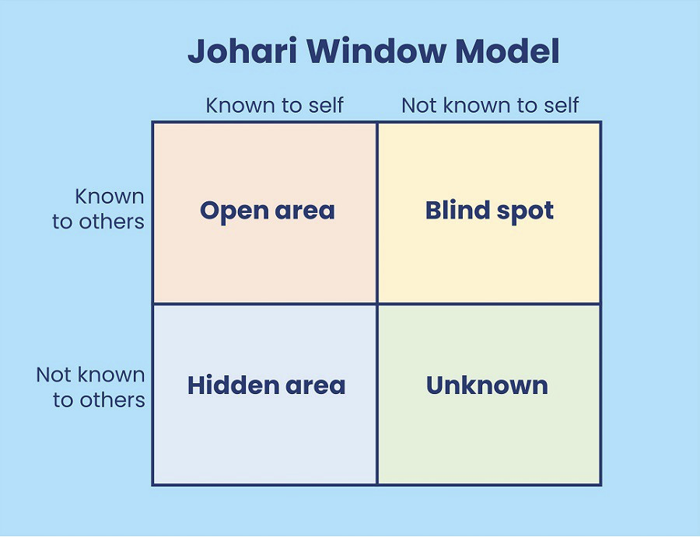

Participants were divided into four groups and given a sheet with adjectives describing personalities, on the bases of which following steps were to be followed.
Step 1 : To write about themselves.
Step 2 : To write about the different group members.
Step 3 : Prepare the a of the list according to the Johari window. (Open area, blind spot, hidden area)
Step 4 : Prepare answers to the following questions:
Did I discover anything new about myself?
A personality trait that affects my work?
Three - four qualities that I would like to continue?
Aspects that I need to work upon?

(2) Activity

Activity description
Participants were asked to estimate the number of blocks they would be able to put on above the other of the total 20 blocks in the time frame of two minutes with their eyes open and closed.
Following participants were divided into groups to perform their individual activity.Each participant covered a cloth on their eyes and were asked to build blocks, record the number of blocks standing at the end of two minutes.
Reflection - Findings
The scores of each individual were compiled and the trends were studied.
  - Some individuals stopped when they achieved their goal even when they had the opportunity to continue to try.
  - The estimated target number of blocks reduced for closed eyes, implying risk mindset (we tend to reduce the target).
  - Clarifying than assuming -
The first person to perform ,took the initiative without questioning the sequence process due to the assumption that it was expected out of him/her rather than discussion in the group.Creating questions within oneself about the members.

Understanding mindsets

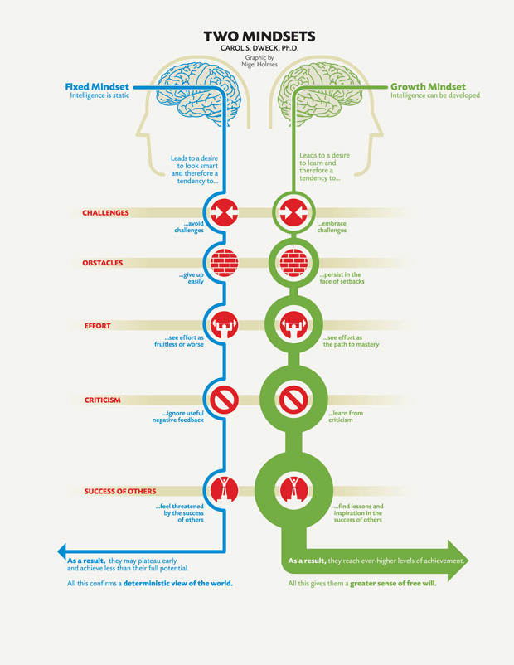
With the reflection of the previous activity it was observed that there are two types of mindsets: fixed and growth.
The growth mindset continuously tries to learn and accept in all situations but not necessarily an individual belongs to the growth mindset in all situations or in fixed.
Subjectivity plays a role in these situations.

Discussion and implementation
How to be of a fixed mindset ?
- To question oneself
- To give constructive criticism to others rather than falling for the influence of judgemental behaviour.
- Try to question the criticism rather than completely accepting or rejecting for better understanding.
- Should not be satisfied but continuously try for betterment.
(3) Activity
A volunteer was called to perform an activity where she was instructed to fill a utensil provided with lentils followed by 5 balls but all balls couldn't fit in the utensil even after several attempts.
Another method was initiated first the balls were placed inside the utensil but this time 2 extra balls were added followed by the lentils but this time the utensil could be packed and it did not overflow.
The lentils filled the space between the balls.
Discussion
Understanding of the activity with metaphors.
- Ball denoted bigger efforts.
- Utensil denoted time.
- Lentils in the former method denoted to be prioritisation.
- What did the lentils denote after being able to settle in the utensils?
- Negotiation
- Interest
- Impact
- Deadline

Understanding prioritisation of work
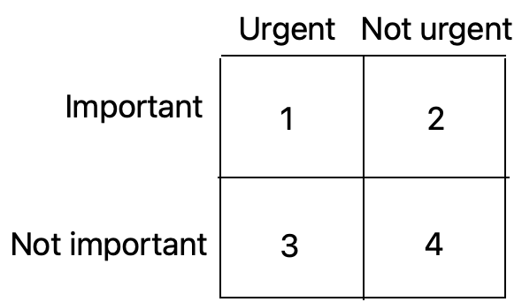
1 – urgent and important work
2 – not urgent but important
3 – not important but urgent
4 – neither urgent nor important

Discussions
- How to distribute work on the bases of urgency and importance under the four combinations ?
- The sequence of work in the following four combinations and whether the combination of 2 or 3 should be prioritised?
- What are incidents of procrastination that lead combination 2 to 1 ? (habit of working at the end moment)
- Opportunities lost due to procrastination causing no space to avail new ?
- The present workshop fits in which combination ?
Findings/learnings
- General sequence of work should be 1–3–2–4
- 3 combinations should be prioritised over 2 due to dependency of others on it.
- The fourth combination should be avoided , these days it's usually social media.
- Planning a daily schedule on the basis of urgency and importance.
- Acquiring new skills can replace social media in combination 4.
- General priorities in our lives
- Health
- Relationships
- Time planning

DAY 2
22 JANUARY’ 2023
Session 3

Reflection
Self management than time management
Activity
Understanding team and group
Execution through Activity
Understanding team
Execution through Activities
Understanding collective work in organisations other than our team specific work.

(1) Reflection
Reflection and personal learnings from the previous day were shared.
- Time management
- व्यवारिक समझोता
- To motivate teammates
- To-do list
- Refraining from gossip

Understanding time management -“Self management”
Time is fluid, it will keep on , we cannot manage it but it is rather ourselves that we have to manage.

Understanding team and group

The activity
A chart paper comprising all the alphabets in random order,in 6 lines starting with one alphabet in the first then increasing with every line and so forth.
10 seconds were given to memorise the chart and the following 2 minutes to write.
Each correct alphabet denoted a point , a total being 26 points.
Conduction
Scores of individuals were assembled with the average between 5 to 9 points.
Then in random order individuals were distributed and previous scores were assembled with the context of the group to increase the possibility.
The average being 14-17.
Activity
The previous groups were made into a team and were asked to perform again but this time together and had the scope to strategise.
Conduction
This time the average was 22.

Discussion
The difference between team and group on the basis of the two activities.

Group | Team
Individual performance connected together but not performed neither related. | Coming together to perform and division of work.  - Planned together  - Organised  - Collective objective  - Division of work according to capabilities  - Formation of support structure  - Collective accountability  - Division of Responsibility

Reflection of the team activity
- Occurrence of confusion of task division causing repetition of one task twice and a part left.
- Method of division of task
- Occurrence of assumption
- Lack of follow through
Execution of the reflection points for strategizing team
- Micro planning
- Clarity
- Planning
- Clear Objective
- Clear roles
- Division of work
- Capability building
- Discussions - inclusive , acceptance
- Motivation
- Situational leadership than fixed
- Forming terms and conditions
- Collective accountability
- Having back up
- Having review, analysis meetings
- Strengthening bonds
- Having fun
The activity
Forming a circle and holding hands at all time then passing the hula hoop by moving through it one after the other.
The conduction
Participants were divided into 2 groups and performed the activity thrice each time estimating the time of completion.
The first estimation was taken individually from all members but the latter was decided by the group.

Reflection
Group 1 -Faced Challenges which caused unsatisfied performance.
- The different understanding of the objective of the task.
- External factors influenced the performance of some members.
- Multiple sources of information.
- Forgot to have fun.
- Lack of questioning.
- Accountability -Difficulty in understanding the responsibility of both individuals than one.
- Haste
- Repetition of the same mistake despite recognising it.
Group 2 - Procedure decided leading to satisfied performance
- Accepted challenge
- The fun element was not forgotten.
- Assessed their mistakes.
- Calm throughout the process.
- No one leadership but collective.
- Motivating each other.

Activity
Participants were divided into 4 groups and the leaders were called separately to explain the task.
The activity
The groups were asked to blindfold their members according to their strategy and they would follow the instructions to reach a spot according to the numbers distribution and if one participant steps on the wrong object then all the group have to start again.
The time limit to finish the activity was given to be 30 minutes.
Reflection
- Not limiting ourselves to our work group as together we serve the same objective.
- Some members of the group felt left out- need to work on different methods of inclusion.
- Should have been more organised by the different leaders considering their own work group.
- Patience was a key aspect.
- Trusting the leader

DAY 3
23 JANUARY’ 2023
Session 4

Activity
Discussion, learning
Some question and discussions
Communication
Activities
Reflection
Model for clear communication

(1) Activity
The activity Participants were divided into 3 groups and were provided with 10 ropes of each ring , each holding ends and had to balance the ball with ropes.
All groups had to reach at a common point and place the balls balancing together.

Discussions
With the perspective of the organisation what did the elements of the activity meant.
Ball - project delivery
Stand-bigger mission
Rope-
- Efforts
- Balance
- Plan
- workers
Ring -
- Foundation
- Objective
- Leader
- Organisation

Learning
- Starting with different projects but coming together, balancing each other's projects.
- The role of the ring for coordination between teams shoul not be sole dependent for decision making and functioning.

Further discussions
- Are the roles defined ?
- Is the nodal point for clarity of project emphasis upon ?
- The awareness of the roles of the teammates
- Is documentation clarity given emphasis ?
- Limiting work to job description
- Are job descriptions clearly defined ?
- Is there a further need to add work (S.O.P) other than in job description ?
- How to build efficiency of the leadership team?
- How to avoid overlap and shadowing ?

(2) Communication
Essential requirement for clarity and better understanding of work— communication.

- Authenticity - questioned
- To listen than to reply
- Confirming by repeating
Activity
The participants were asked to form a circle and given a card each of four different colours, each having the hierarchy.

Participants were suppose to exchange cards thrice , the ones having the highest card were suppose to assemble in the centre following a chain of replacing each other's position in descending order took place and in the end the participant with lowest card in hierarchy to assemble in the centre.

The activity took place thrice eac time reducing the time but each time having confusions despite being explained again and again.
Reflection
- Multiple sources of information.
- Lack of focus.
- Difficulty in accepting mistakes.
- Not asking questions.
- Assumption of the speaker that the listener understood.
- Difference in capacity to understand.
- Repetition of the same mistake.
Activity
Two participants were asked to give verbal instructions explain two different drawings which the listener would draw.
The first drawing had no point of reference and random structures while the second drawing had context.
Reflection
- Importance of strategic communication method.
- Assumption is a common mistake.
- Patience
- Importance for having a context of the information.

Model for clear communication
CARE
Context
Action
Result and repercussion
Extension(additional information for details)

DAY 3
23 JANUARY’ 2023
Session 5

Learning implementation
- Project plan
- Personal learning
- Identified a habit that will try to continue.
- Identified a habit that will try to discontinue.
- A habit that will start from now
- Personal action plan

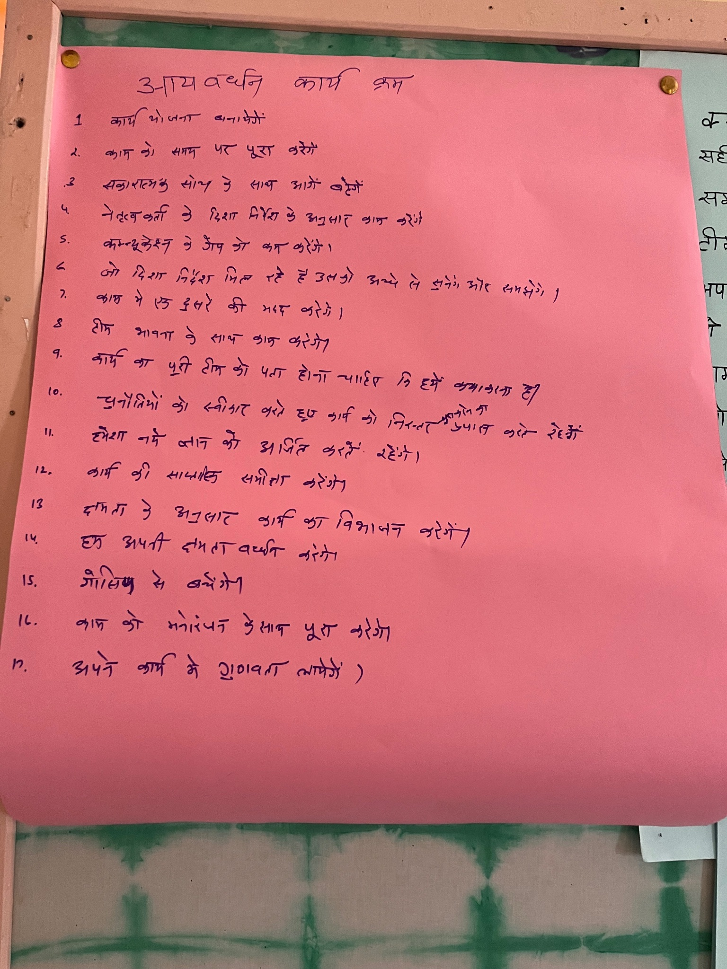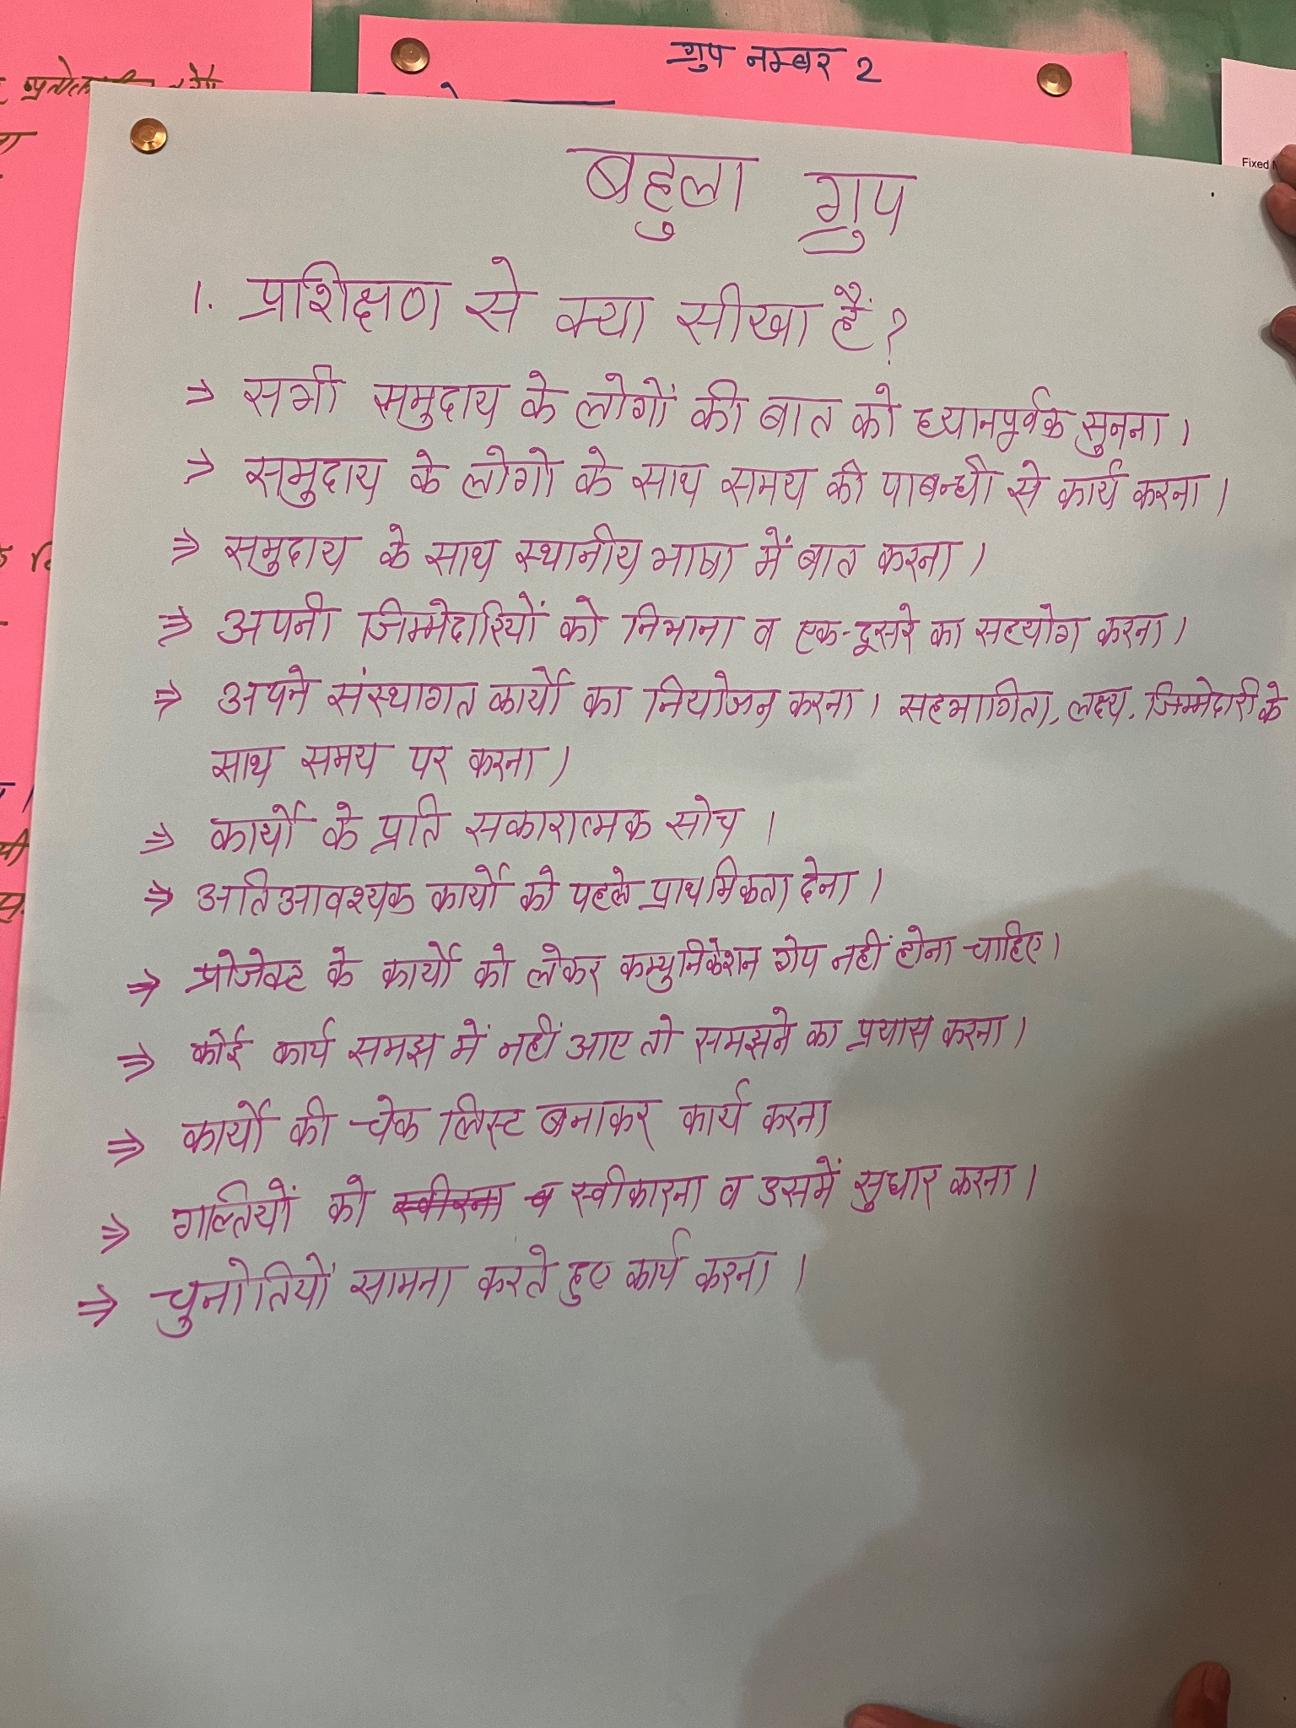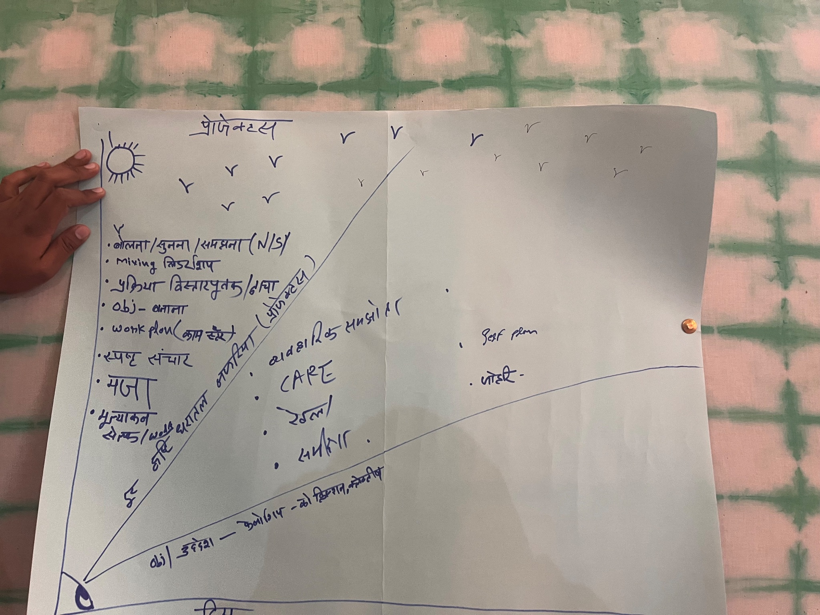
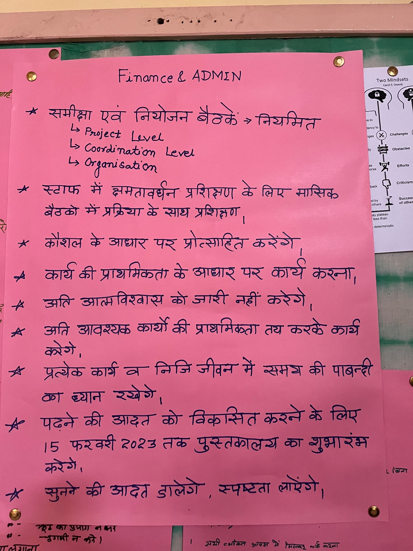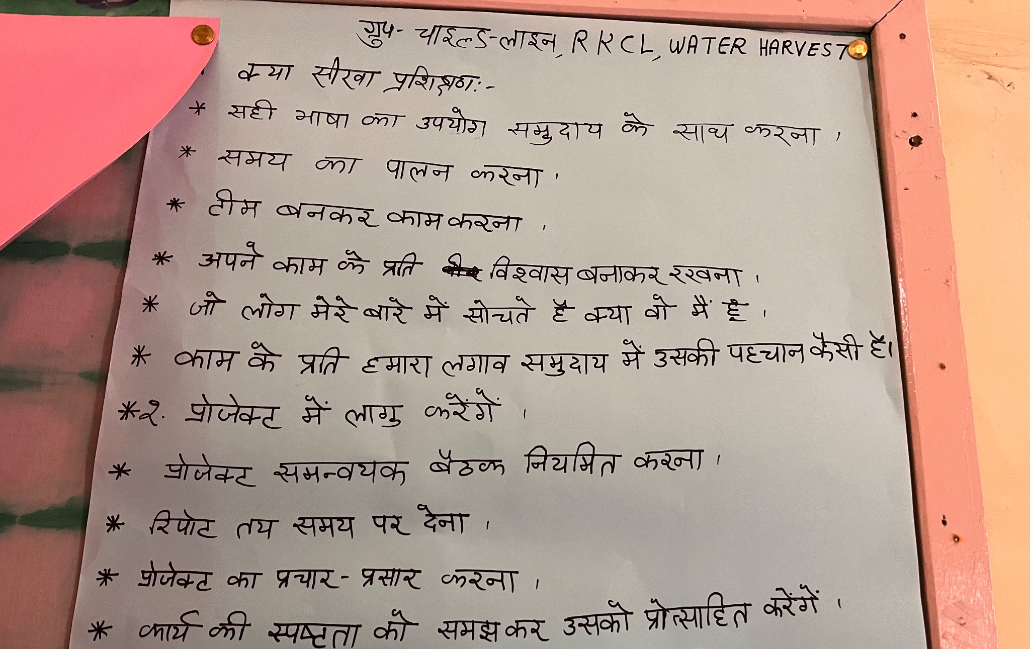
Feedback
- The vision and design were well researched and it was neither restricting nor eliminating.
- Method of games made it interactive.
- Certain aspects forgotten in the years of work could be remembered.
- Easier to understand.
- Appreciation for the smile and patience of the facilitator.
- Open for questions and non judgemental behaviour made it easier to participate.
- Helped gaining confidence in speaking.
- Seek more learning opportunities.

