Yearly Project Impact Report 2023
July 2022 to June 2023
Organisation details
Name of the Organisation |  | Urmul Seemant Samiti
Contact person and number |  | SURAJ SINGH, 9711675919
Vision and mission |  | Vision - Breaking barriers for promoting desert-centric social innovations.  Mission - To design and implement a package of sustainable development services leading to direct benefit for communities of the desert.
Brief about the NGO programs |  | Urmul Seemant has created strategies for inducing community-driven socio-developmental changes by creating programs, improving them, sustaining them, and finally delivering them over to communities in the challenging and inhospitable parts of rural Rajasthan in the Thar Desert.  Urmul's work is guided by a sense of optimism and faith in people's ability to affect much-needed social change via their efforts. Most of the work focuses on farmers, herders, and children, among society's most vulnerable and neglected groups. To combat the grave impact of the 1988 drought, Urmul initiated many interventions around the districts of Bikaner, Churu, Hanumangarh, Jodhpur, Sri Ganganagar, and Nagaur.  Following an integrated development approach, Urmul works on almost all the Sustainable Development Goals. We adopt service delivery platforms, advocacy, and lobbying tools for empowering the marginalised and vulnerable sections of society in over 1000 villages in this desert state of India-thematically working on Health, Education, Livelihood, Environment, Crafts, Agriculture, Mother-Child Care, et al.
Project details
Project Name |  | Bahula: Enhancing Desert Textile and Agri-Dairy Value Chains
Project Brief/Background |  | Bahula Programme is working on enhancing the resilience of Agri-dairy farmers and artisans by promoting the micro-entrepreneurial ecosystem and establishing green enterprises by introducing innovative products from farm-based and non-farm value chains in the market.  The program proposes to work in a focused cluster of 54 villages and its hamlets to develop a model of inclusive & holistic development of community promoting many of the Sustainable Development Goals. Through the program, we target reaching out to around 20,000 people and work on improving livelihood opportunities (Farm & Non-farm based).
Project objective |  | Enhancing Desert Textile and Agri-Dairy Value Chains
Reported for |  | July 2022 to June 2023
Outreach |  | Bikaner District – 36 Villages  Jodhpur District – 18 Villages
Beneficiary group(s) |  | - Women – They are the most vulnerable sections of any society.  - Artisans  - Farmers  - Pastoralist  - Youth Groups
Fund sanctioned for the year |  | 1,00,03,000 INR
Fund utilized for the year |  | 1,00,03,000 INR
Unutilized funds from the previous year |  | 0 INR
Reason for utilization |  | To Promote social enterprise through the development of textile and Agri-dairy based value chain
Project Methodology
Key Activities conducted | - Give Input Support to 420 Farmers and buy back 7.1 tonnes of organic produce as well.  - Organised 5 business youth cadre training.  - Revived Naya Ujala Mahila Kisan Producers FPO for the Institutionalisation of the community.  - Worked on marketable product development from A2 cow milk.  - Continuous efforts on the market linkage of Agri-dairy products through Bahula Social Enterprise.  - Organised 13 Sheep health camps for the Pastoralist Community and covered  - Organised 13 Fibre-based advanced-level trainings to prepare artisans for marketable product development  - Developed 8 natural fiber-based Marketable products.  - Working on the Magra Brand development in built environment space through Samakhya Sustainable Alternatives (Pvt Ltd) social enterprise
Deviation from the original targets set for the quarter | -
Key challenges faced | - The delayed initiation of the program has led to the entire team rushing toward the deadlines to match the pace of the program’s timelines.  - Community mobilization during the cropping season is challenging because the community members move out of the villages to stay in their Dhanis (hamlets) so it gets tough to get a hold of them.  - Running the established unit with semi-skilled workers and community  - Due to the lack of technical skills in the field workers, capacity building of these workers was essential before they could start working in the community.  - Generating market awareness and readiness towards organic products and justifying the costs
HDFC Bank’s engagement in the project | - Product development support for Agri-Dairy and Natural Fiber verticals.  - Marketing cost support for the market linkage of our farmers, pastoralist, and artisan products  - Provide Technical training to understand the monitoring and compliance process for the Project.  - The entire program was designed based on the largest financial and humanitarian support of HDFC bank Parivartan which was helpful to strengthen our both value chains – 1. Agri-dairy chain and 2. Wool value chain.  - Guidance and mentorship in scaling the programme interventions.
Project outcome
Project outcome achieved as against the target set | Activity |  | Tasks scheduled | Tasks achieved | Outcome achieved
 |  |  |  |  | Quantitative | Qualitative
No. of Farmers - 400  Achieved – 420 | 1.1 Package of services including seeds and biofertilizers to promote organic farming |  | Q4/M6 | Completed | 420 | Provided input support to the 420 farmers in the mentioned village - Imamnagar, Chimana, Neniya, Hanumannagar, Bhelu, Sanktok Nagar, Saranpura, Bhaluri, Phulasar Chhota, Phulasar Bada, Barsalpur, Godoo, Bajju Khalsa, Bajju Tejpura, Gadiyala, Charanwala.  Input support covered the process from seeds, bio-fertilizers, and knowledge to market linkages to the farmers.
No. of FPO - 1  Achieved - 1 | 1.2 FPO formation and management |  | Q3/M1 | Completed | 1 | Revived and Supported Naya  Ujala Mahila Kisan Producer  Ltd. FPO. This year the entire process of buyback from farmers was done through this FPO.  In the process of market linkage, a three-tier structure has been developed, the first level is Village Level Committees, the second is Naya Ujala FPO and the third is Bahula Social Enterprise.
No. of Training – 5  Achieved - 5 | 1.3 Business training of youth cadre |  | Q3/M3 | Completed | 5 | - Organized one-day milk handling training in MPU, Bajju, Participants – 10  - Organic farming practices Training, Kota,15 Jan 2023, 5 participants  - Sahaj Dairy Exposure visit, 2nd Feb 2023, 2 participants  - Milk Tasting Training, 17th Feb 2022, 20 participants  - Mineral Mixture Making for cattle, 22nd March 2023, 22 participants
No. of Products – 10  Achieved - 10 | 1.4 Product diversification & raw material support, sampling, and standardisation interventions |  | Q4/M6 | Completed | 10 | Worked on the development of Milk based marketable product range. Around 200 milk producers are linked with the milk processing  Unit. They are direct beneficiaries of our dairy value chain. The developed products detail is given below -  - A2 Cow milk Full Cream  - A2 Rathi Cow milk ‘Fitpure’  - Butter Milk  - Paneer  - A2 Bilona Ghee  - Curd  - Cheshire Hard Cheese  - Halloumi  - Feta  - Meethi Lassi
No. of Month – 8  Achieved – 8 | 1.5 Market Intervention & Engagement |  | Q4/M6 | Completed |  | - Launched Bahula Naturals as a brand and finalized the packaging of the products that go to the market under this brand. Website of Bahula Naturals –  https://bahulanaturals.com/  Organized and participated in various business exhibitions –  - Triveni Kala Sangam Exhibition, Delhi 16th - 20th Dec 2022  - Dastkar Exhibition, Bengaluru 21th -27th Dec 2022  - Bhuj Exhibition, 19th to 28th Jan 2023  - Kota Exhibition, 24th to 25th Jan 2023  - Bikaner Exhibition, 2th to 10th Feb 2023  - Kishangarh Exhibition, 16th to 17th Feb 2023  - NRCC Exhibition, 5th Mar 2023  - ‘Cheese Fiesta, Goa’ 17th to 19th Mar 2023 Camel Milk Cheese Launching event in Goa.  - We showcased our products in an exhibition hosted by HDFC bank in Jaipur on June 2, 2023, at Hotel Arya Niwas and received a very encouraging response from HDFC senior management through Ms. Ashima Bhat, Ms. Smita Bhagat, and Ms. Nusrat Pathan.  - Through A2 Cow Milk, we generated 77,87,215 Rs in income for milk producers in this project year.
No. of Health Camps – 10  Achieved – 13 | 2.1 Organising animal health camps |  | Q4/ M6 | Completed | 13 | We organised 13 Animal Health Camps this year and provided health facilities to more than 5900 sheep & goats. Village-wise details are given below –  - Beethnok, 10th Jan 2023  - Govindsar, 11th Jan 2023  - Narayanpura, 12th Jan 2023  - Imamanagar, 15th Jan 2023  - Narayanpura, 12th March 2023  - Khajoosar, 13th June 2023  - Imamnagar, 14th June 2023  - Khajora, 15th March 2023  - Narayanpura, 2nd May 2023  - Naryanapura, 26th June 2023  - Beethnok, 26th June 2023  - Khajusar, 27th June 2023  - Ranasar, 29th June 2023
No. of Training – 13  Achieved – 13 | 2.2 Fibre-based advanced-level training interventions to prepare artisans and units for premium markets |  | Q4/M6 | Completed | 13 | We conducted 13 fiber-based advanced-level multi-day training. Details are given below -  - Bajju, Wool sorting training, 15th to 16th Feb 2023, participants – 7  - Bajju, Wool spinning training 17th-18th Feb 2023, participants – 7  - Narayanpura, Wool sorting training, 19th - 20th Feb 2023, Narayanpura, Participants – 9  - Bajju, Wool grading training, 24th May 2023 to 26th May 2023, Participants – 31  - Chimana, Wool grading training, 26th May to 28th May 2023, 13  - Chimana, Wool grading training, 1st June to 3rd June 2023, Participants – 16  - Narayanpura, Wool grading training, 3rd June to 5th June 2023, Participants – 17  - Bajju, Felt making training, 7th June to 9th June 2023, Participants – 25  - Bajju, Felt products making training, 10th June to 12th June 2023, Participants – 25  - Weaving, 14th to 18th June 2023, Participants - 15  - Bajju, Wool spinning training, 25th June to 27th June 2023, Participants – 11  - Chimana, Wool spinning Training, 25th June to 27th June 2023 Participants – 11  - Chimana, Wool grading training, 28th June to 30th June 2023 Participants - 13
No. of Products – 5  Achieved - 8 | 2.3 Product sampling, innovation, and development |  | Q4/M6 | Completed | 8 | Natural Fibre Production Centre catering to wool producers and artisans. We developed 8 products from Indigenous wool this year –  - Felt – 2MM, 4MM, 8 MM, 12 MM  - Batts  - Rectangular Acoustic cloud  - Hexagonal Acoustic clouds  - Sound Baffle  - Hand-Woven Acoustic panel  - Roller and Roman Blind  - Tapestry  Apart from these, we set up the handlooms and the weaving unit. The team collectively worked to  kickstart the weaving unit.
No. of Month – 8  Achieved – 8 | 3.3 Crafts Ecosystem Outreach & brand building |  | Q4/M6 | Completed | 10 | - Launched Magra Brand in Built Environment space in the month of July 2023.  - Ace Exhibition Bangalore, from the 12th to the 17th of October 2023. The team had a great time interacting with industry experts.  - Triveni Kala Sangam, Delhi dated 16th to 20th Dec 2022, Desi wool exhibition  - Participated in Wool Expo on 3rd Feb 2023 at Kisan Hatt, Bikaner for 10 days, Displayed all the wool-made products like, toiletry pouches, laptop sleeves, wire detanglers and etc.  - On 22nd June 2023 Got the order from Social Alfa to Insulate a 10,000 Sq ft area in Lahaul Spiti, Himachal  - Developed the website of the Magra brand for online Marketing and brand building.  - Insulated a passive insulation room in Cheemana which is developed under the dairy vertical with the support of the Selco Foundation.  - Created a business of 11,70,546 Rs through Samakhya Social Enterprise within a year.
Key learnings | - We have to provide a sustainable source of livelihood to the community  - Community contribution in any work is helpful in inculcating a sense of belonging and ownership in them.  - Direct linkage to the market is the first requirement to enhance the livelihood of the primary producer.  - The community is ready to embrace innovation so we cannot function as a mere service provider. We have to present innovations to the community that work their problems and increase livelihood opportunities  - The community is ready to embrace innovation so we cannot act as a mere service provider. We have to present innovations to the community that solve their problems and increase their livelihood opportunities.
Any feedback that you would like to share with the CSR Team | It has been a great experience to work with HDFC Bank CSR and the supportive team of management. Even sitting at a distance the team understood the challenges NGOs face on the grassroots and supported us through it all.
Communication
HDFC Bank branding, media coverage, etc. | 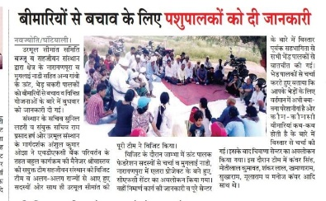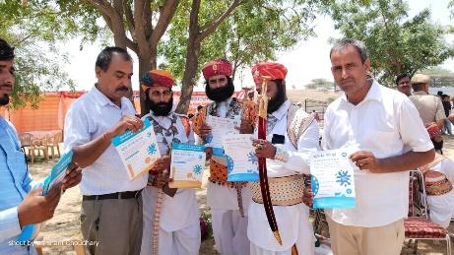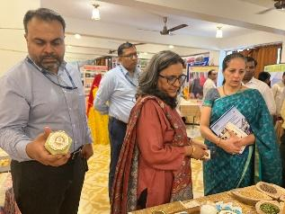  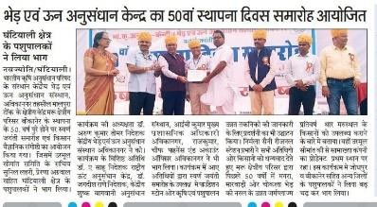

Case Stories

- ‘Bahula Sangam’ Community Instant Milk Chiller & Collection Centre, Phulasar Chhota, Bikaner
In the Thar Desert Phulasar Chhota Village of Bikaner, a remarkable micro-entrepreneurship initiative named 'Bahula Sangam' has emerged as a pivotal solution to enhance the sustainable livelihood of local A2 Rathi Cow milk producers. We set up a solar-based Instant Milk Chiller & Milk Collection Centre with convergence. This cutting-edge technology rapidly cools the freshly collected milk, effectively extending its shelf life and maintaining its nutritional value. Bahula Sangam serves as a central collection point for A2 Rathi Cow milk produced by local farmers. This eliminates the need for individual transportation to distant dairies, reducing logistical complexities and expenses.
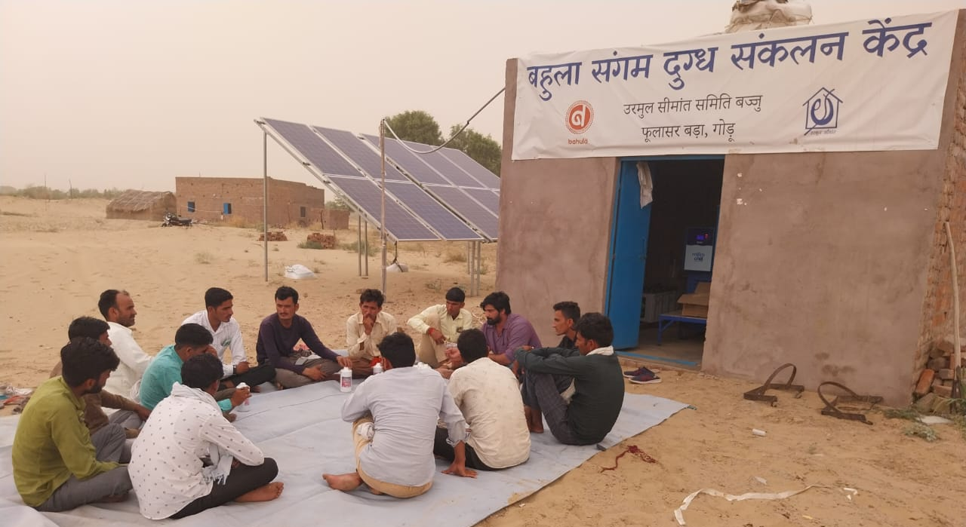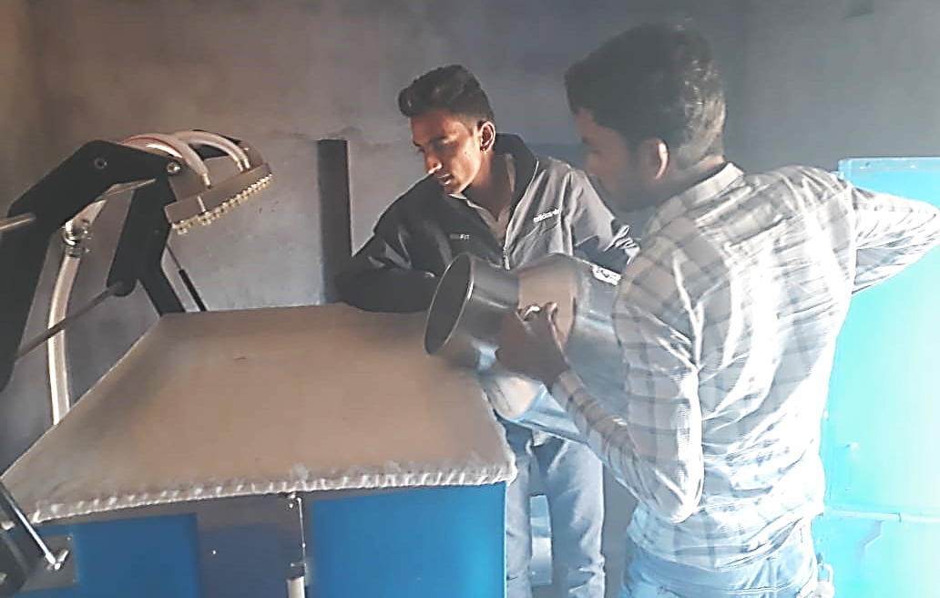
The Bahula team is dedicated to maintaining the purity and authenticity of Rathi milk. Stringent quality control measures are implemented to ensure that only the finest, unadulterated milk is accepted. As a community-driven endeavor, The Bahula is committed to ensuring that milk producers receive a fair price for their efforts. By minimizing intermediary costs and maintaining direct relationships with farmers, the center plays a crucial role in empowering local producers. We generated a direct income of 19,17823 Rs to the milk producers associated with Bahula Sangam till June 2023.
The entire operation is run by a community member who acts as a micro-entrepreneur. This not only generates livelihood opportunities within the village but also fosters a sense of ownership and responsibility among locals. On the other hand, by utilizing solar power for milk chilling, Bahula Programme contributes to the reduction of carbon emissions and promotes sustainable practices within the community.
Key Outcomes
- Extend the shelf life of A2 Rathi Cow milk.
- Minimize transportation costs by providing a local collection point.
- Empower local milk producers by ensuring fair pricing.
- Preserve the purity and authenticity of Rathi milk.
- Direct Income of 1917823 Rupees of Milk Producers.
- Reduce Carbon emissions.
- Name of the beneficiaries- Kayamdeen, Village- Muglainadi, Narayanpura, Bikaner
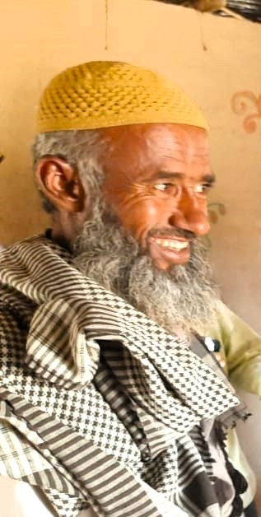
Kayamdeen is a pastoralist residing in Narayanpura Village, Bikaner district. With a 40-sheep herd, Kayamdeen plays a crucial role in supporting the livelihoods of his community. By operating a Common Facility Centre established by Urmul Seemant Samiti, Kayamdeen has been able to provide essential services such as health, fodder, water, and machine shearing facilities to fellow pastoralists in the region. Jodhpur Zila Parishad CEO Mr. Abhishek Surana also visited the CFC centre and apricated the model. He is also enthusiastic to replicate this model in the other region of the Jodhpur district for the pastoral community.
Like many pastoralists in the area, Kayamdeen previously faced numerous challenges in maximizing the value of his sheep's wool. He relied on mediators who offered low prices, typically ranging from 30 to 60 rupees per kilogram.
The intervention of the Bahula Programme proved to be a turning point in Kayamdeen's life. The program focused on two critical aspects: wool quality enhancement and direct market linkage. Kayamdeen adopted several measures to enhance the quality of his wool. Firstly, he began bathing the sheep before shearing. Additionally, Kayamdeen switched from traditional scissors to using a shearing machine for more efficient and precise wool removal. Furthermore, Kayamdeen learned the importance of grading the wool according to its quality.
The combination of these efforts led to a substantial increase in the price Kayamdeen received for his wool. Instead of the meager 30-60 rupees per kilogram offered by mediators, he now commands a significantly higher range of 100-120 rupees per kilogram. This substantial rise in income not only improved Kayamdeen's financial stability but also created a ripple effect within the pastoralist community, inspiring others to adopt similar practices.

