Yearly Project Impact Report
Organisation details
Name of the Organisation |  | Urmul Seemant Samiti
Contact person and number |  | SURAJ SINGH, 9711675919
Vision and mission |  | Vision - Breaking barriers for promoting desert-centric social innovations.  Mission - To design and implement a package of sustainable development services leading to direct benefit for communities of the desert.
Brief about the NGO programs |  | Urmul Seemant has created strategies for inducing community-driven socio-developmental changes by creating programs, improving them, sustaining them, and finally delivering them over to communities in the challenging and inhospitable parts of rural Rajasthan in the Thar Desert.  Urmul's work is guided by a sense of optimism and faith in people's ability to affect much-needed social change via their efforts. Most of the work focuses on farmers, herders, and children, amongst society's most vulnerable and neglected groups. To combat the grave impact of the 1988 drought, Urmul initiated many interventions around the districts of Bikaner, Churu, Hanumangarh, Jodhpur, Sri Ganganagar, and Nagaur.  Following an integrated development approach, Urmul works on almost all the Sustainable Development Goals. We adopt service delivery platforms, advocacy, and lobbying tools for empowering the marginalised and vulnerable sections of society in over 1000 villages in this desert state of India-thematically working on Health, Education, Livelihood, Environment, Crafts, Agriculture, Mother-Child Care, et al.
Project details
Project Name |  | Bahula: Enhancing Desert Textile and Agri-Dairy Value Chains
Project Brief/Background |  | Bahula Programme is working on enhancing the resilience of Agri-dairy farmers and artisans by promoting the micro-entrepreneurial ecosystem and establishing green enterprises by introducing innovative products from farm-based and non-farm value chains in the market.  The program proposes to work in a focused cluster of 54 villages and its hamlets to develop a model of inclusive & holistic development of community promoting many of the Sustainable Development Goals. Through the program, we target reaching out to around 20,000 people and work on improving livelihood opportunities (Farm & Non-farm based).
Project objective |  | Enhancing Desert Textile and Agri-Dairy Value Chains
Reported for |  | July 2021 to June 2022
Outreach |  | Bikaner District – 36 Villages  Jodhpur District – 18 Villages
Beneficiary group(s) |  | - Women – They are the most vulnerable sections of any society.  - Artisans  - Farmers  - Pastoralist  - Youth Groups
Fund sanctioned for the year |  | 29171040 INR
Fund utilized for the year |  | 29054453 INR
Unutilized funds from the previous year |  | 116587 INR
Reason for utilization |  | To Promote the social enterprise through the development of textile and Agri-dairy based value chain
Project Methodology
Key Activities conducted | - Give Input Support to 642 Farmers and buy back the organic produce as well.  - Established 2 Fibre processing centres in Jodhpur and Bikaner districts.  - Set a Natural dyeing unit in Bajju.  - Organised fourteen trainings related to spinning and weaving which covered 354 artisans.  - Upgraded the Milk processing unit in Bajju with infrastructure and machinery support.  - Mobilised a group of 60 Pastoralists in Narayanpura village and gave them cattle feed, vaccination, and innovation (shearing machine, portable carding machine, etc.) support.  - Organised Two cluster-level organic farming practicing training. Participated  - Mobilised the artisan group through 42 community meetings and covered 947 women.  - Launched Bahula Foods Private Limited as an Agri-dairy market brand and Magra as a Build-environment brand.
Deviation from the original targets set for the quarter | -
Key challenges faced | - The delayed initiation of the program has led to the entire team rushing towards the deadlines to match the pace of the program’s timelines.  - Community mobilisation during the cropping season is challenging because the community members move out of the villages to stay in their Dhanis (hamlets) so it gets tough to get a hold of them.  - Running the established unit with semi-skilled workers and community  - Due to the lack of technical skills in the field workers, capacity building of these workers was essential before they could start working in the community.  - Generating market awareness and readiness towards organic products and justifying the costs
HDFC Bank’s engagement in the project | - Financial support in the setup of 2 Fibre processing centres, Milk processing Unit upgradation, Natural dyeing Unit, etc.  - Marketing cost support for the market linkage of our farmers, pastoralist and artisan products  - Provide Technical training to understand the monitoring and compliance process for the Project.  - The entire program was designed based on the largest financial and humanitarian support of HDFC bank Parivartan which was helpful to strengthen our both value chains – 1. Agri-dairy chain and 2. Wool value chain.  - Guidance and mentorship in scaling the programme interventions.
Project outcome
Project outcome achieved as against the target set | Activity |  | Tasks scheduled | Tasks achieved | Outcome achieved
 |  |  |  |  | Quantitative | Qualitative
No. of Machine 5  Achieved – 6 | 1.1 Upgradation of dairy Infrastructure unit for milk processing and decentralised collection |  | Q1/M3; Q2/M4 | Completed | 6 | Advancing the milk processing unit through this up-gradation of machines (Pouch packaging machine, steel vats, Butter Churner, Dump tank, Mini milk chiller, etc.)
No. of farmers – 600  Achieved - 642 | 1.2 Package of Farm inputs to enhance green fodder production |  | Q1-Q2/M2, M3, M4, M5 | Completed | 642 | This support enabled farmers to adapt to organic farming practices. the total land size we transformed into organic is 199 acres. Production of over 80 tonnes of organic wheat, black wheat, cumin, chana, and mustard in the region.
No. of products – 8  Achieved - 8 | 1.3 Dairy Product diversification: Sampling and standardisation interventions |  | Q3/M9 | Completed | 8 | The milk processing unit is being run as per premium quality and hygiene standards. Training on the development of a range of dairy products - milk, ghee, artinsala cheese, curd, buttermilk, butter, paneer, etc
No. of system – 1  Achieved - 1 | 1.4 Developing ERP and other technology systems to strengthen the Agri-dairy value chain |  | Q1/M2 - Q4/M10 ongoing | Completed | Developed ERP System | Developed a technology platform ERP to enable traceability of source and facilitate a unique user engagement business approach.
No. of months – 12  Achieved – 12 | 1.5 Market intervention and engagement |  | Q2/ M5, M6, Q4/ M10, M11 | Completed | 12 | Launched Bahula the brand for Agri and dairy product market linkages
No. of Meetings – 36  Achieved – | 2.1 Community meetings to mobilise artisans |  | Q1/M1, Q2/M4, Q3/M7, Q4/M10 | Completed | Mobilised 938 artisans through these community meetings | The meeting helped us to mobilise the community
No. of Unit – 2  Achieved - 2 | 2.2 Indigenous Fibre Processing Centre - 2 Crafts Centre Infrastructure & machine support |  | Q1/M3-Q2/M5 | Completed | 2 centres for fibre processing developed | Fibre Processing Centres catering to wool producers and artisans from 50 villages for end-to-end wool processing.
No. of Artisan Women - 250  Achieved – 354 | 2.3 Fibre Processing and quality enhancement interventions |  | Q2/M6-Q3/M8 | Completed | Organised 14 trainings to trained the women | Equipping women artisans through training on spinning, weaving, and carding for different usages of wool.
Natural dyeing Unit – 1  Achieved – 1 | 3.1 Production centre for indigenous textile dyeing using sustainable principles |  | Q1/M1-Q3/M9 | Completed | 1 Natural dyeing unit | Established an advanced centre for high-quality fibre dying, developing and producing various fibre, cloth and dyes - tensile strength, dye absorption, natural softeners, etc.
No. of Product - 20  Achieved - 20 | 3.2 Product development of organically dyed indigenous textile - Sampling Finishing, Packaging |  | Q1/M1-Q3/M9 | Completed | 12 | Ecosystem creation exercise with natural fibres across three value chains: 1. Textile value chain - Yarn, Clothing, Accessories 2. Built Environment - Felts, Panels, Batts 3. Agriculture - Farm Compost
No. of Month – 10  Achieved – 10 | 3.3 Crafts Ecosystem Outreach: Media campaign, branding to promote natural fibres and natural dyes |  | Q2/M5-Q3/M9 | Completed | 10 | Conceptualised and marketed the entity to link fibre products to markets under the name of Magra.
No. of HH – 50  Achieved - 2602 | 4.1 Need Assessment |  | - | Completed | 2602 HH | The survey helped us to identify the need of the community and we included the work area which required support accordingly
No. of Month – 12  Achieved - 12 | 4.2 Process Documentation and media engagement- impact report and AV documentation of the project, branding |  | Ongoing | Completed | 3 Program videos  Agenda setter, Agri Dairy, Wool value chain | To prepare such videos so that our work can be presented in an effective visual way.
Key learnings | - We have to provide a sustainable source of livelihood to the community  - Community contribution in any work is helpful in inculcating a sense of belonging and ownership in them.  - Direct linkage to the market is the first requirement to enhance the livelihood of the primary producer.  - The community is ready to embrace innovation so we cannot function as a mere service provider. We have to present innovations to the community that work their problems and increase livelihood opportunities  - The community is ready to embrace innovation so we cannot act as a mere service provider. We have to present innovations to the community that solve their problems and increase their livelihood opportunities.
Any feedback that you would like to share with the CSR Team | It has been a great experience to work with HDFC bank CSR and the supportive team of management. Even sitting at a distance the team understood the challenges NGOs face on the grassroots and supported us through it all.
Communication
HDFC Bank branding, media coverage, etc. | 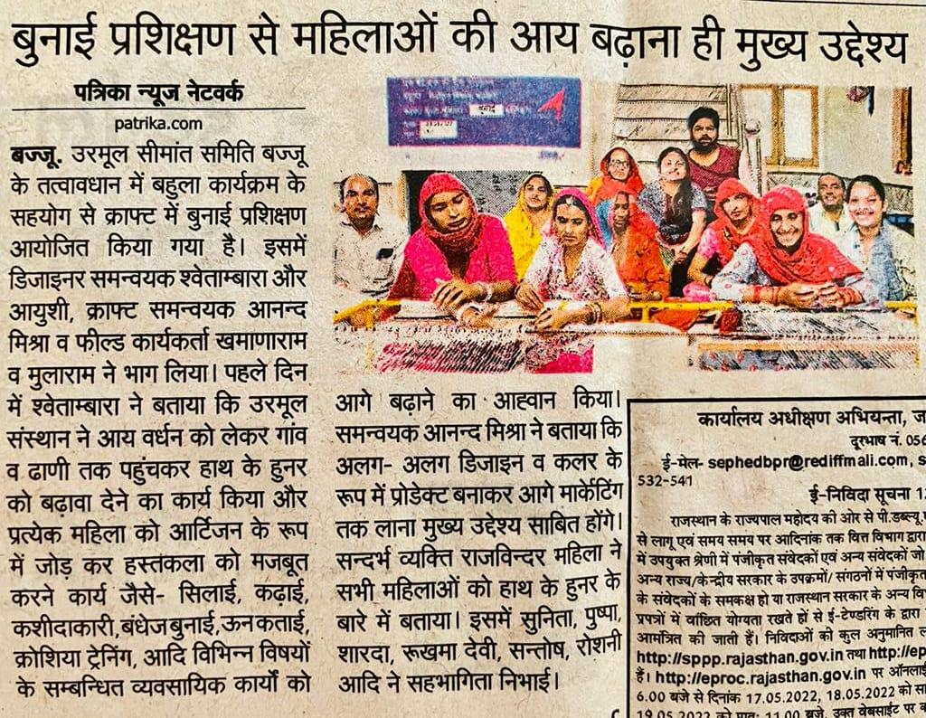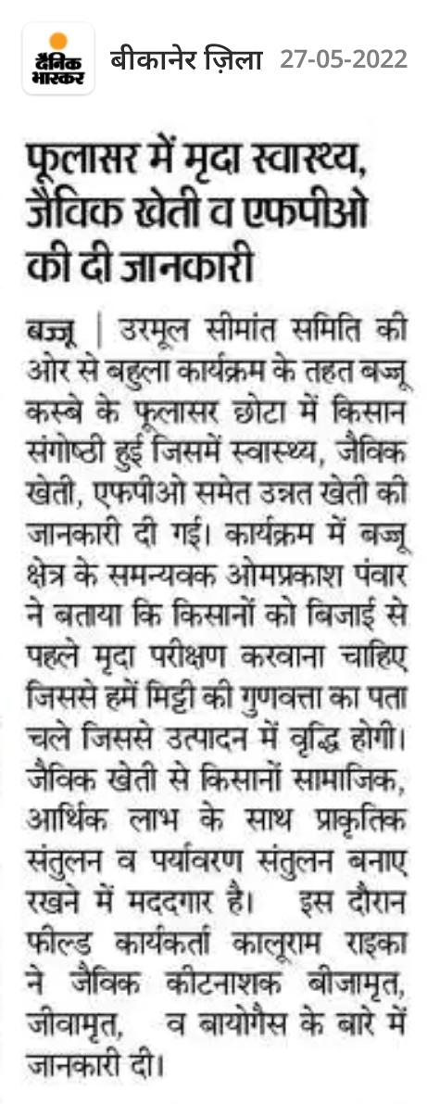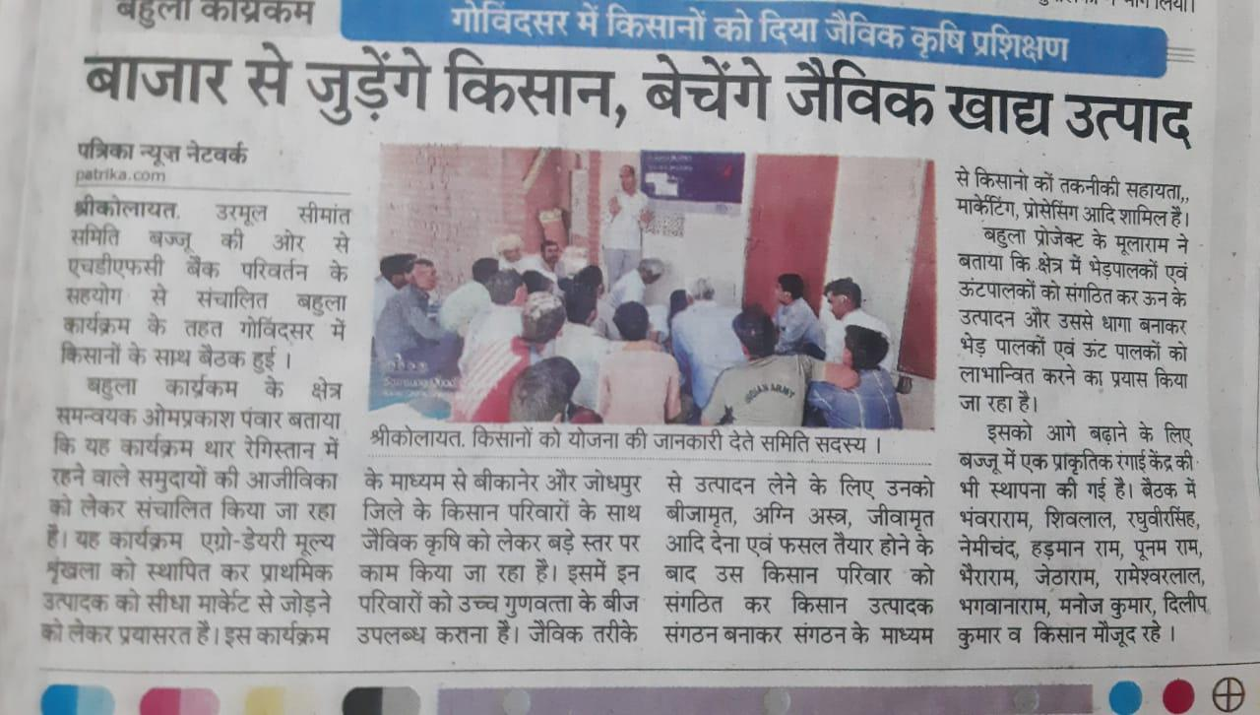  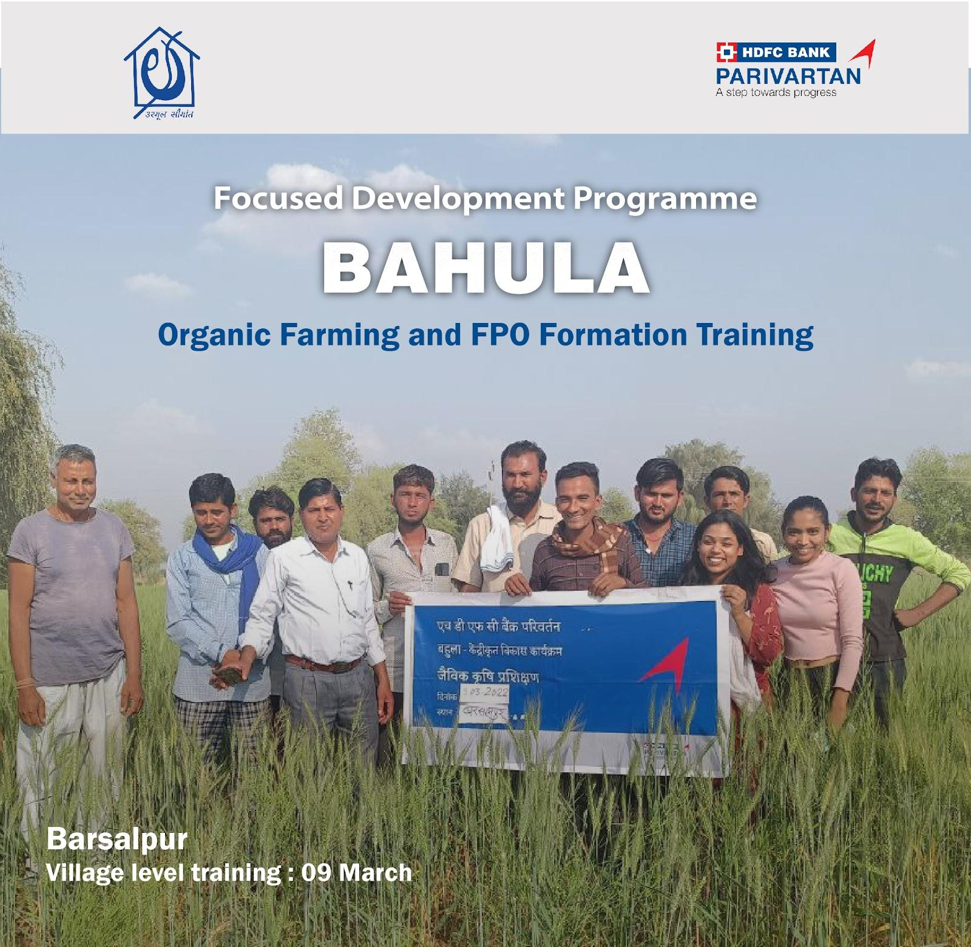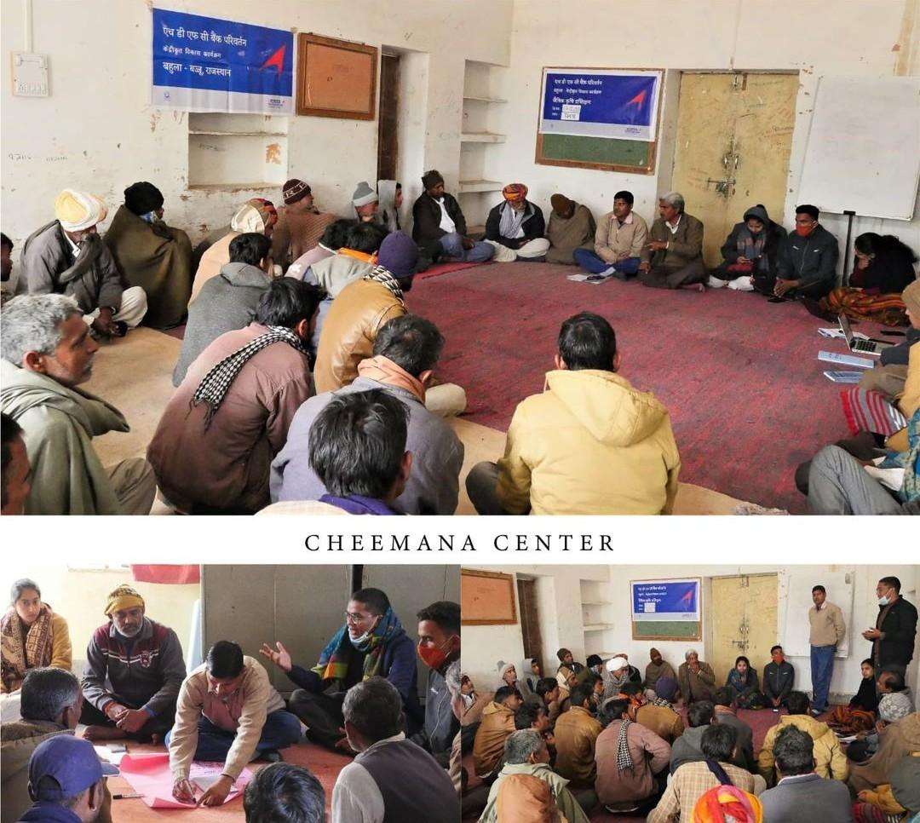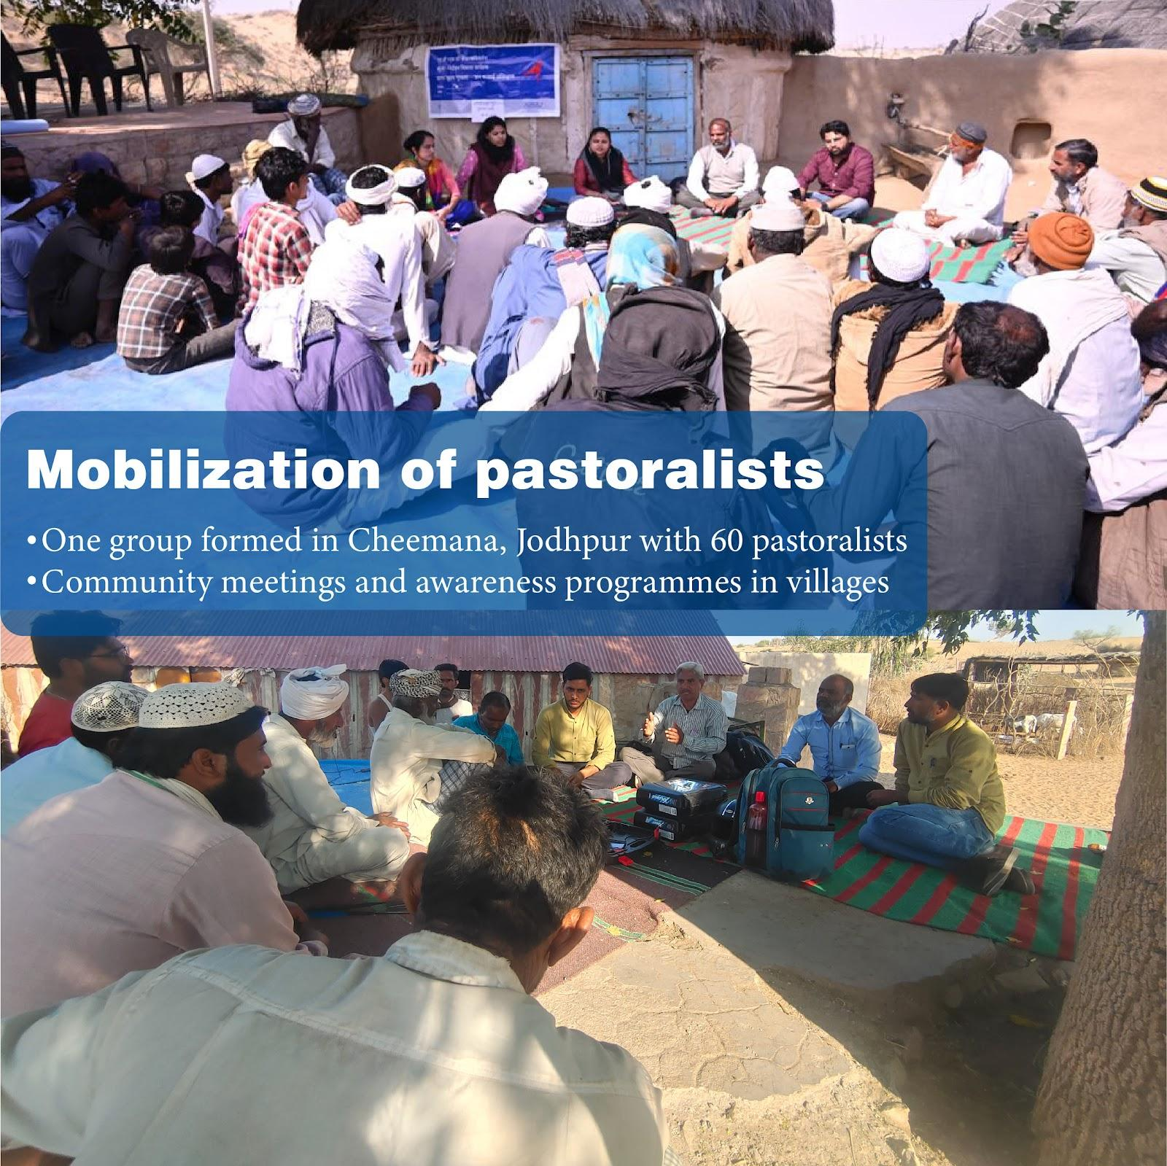  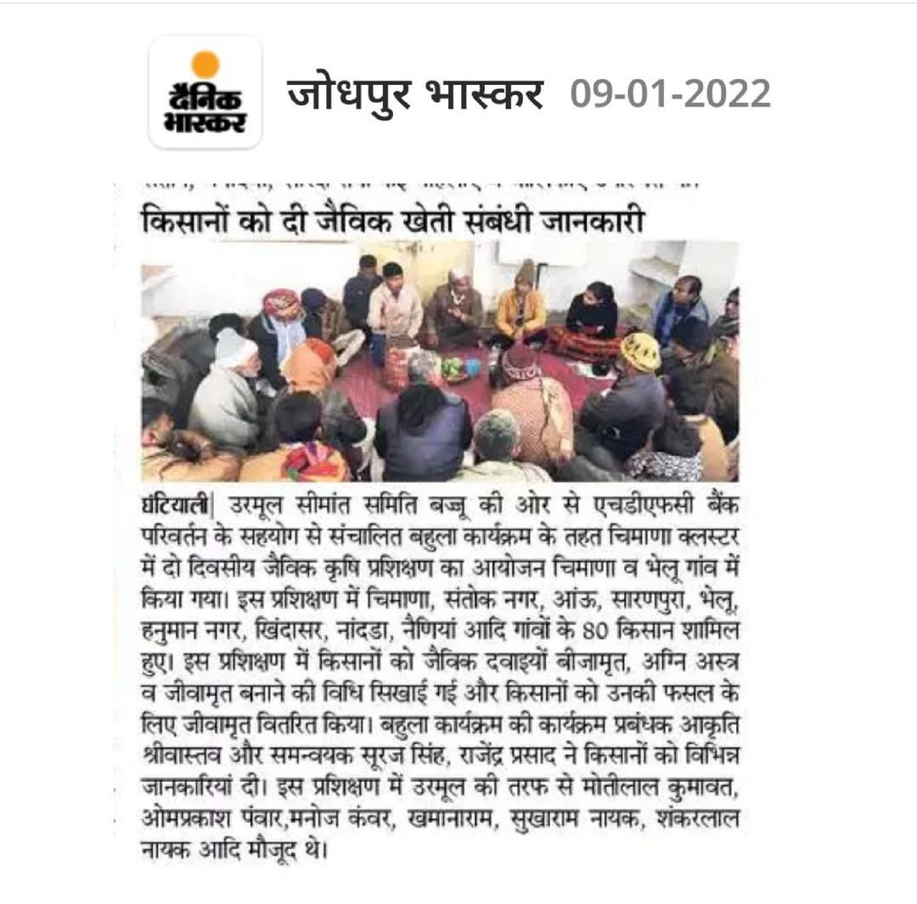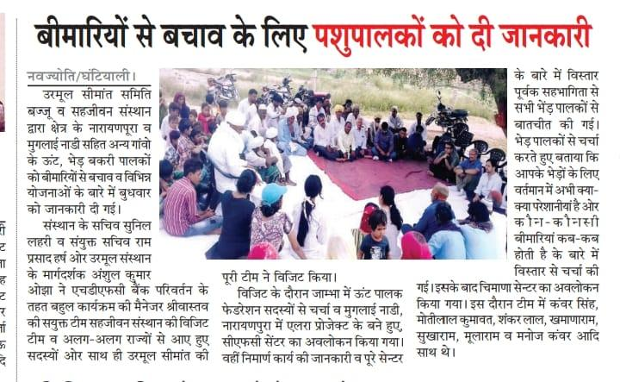

Case Stories

- Name of the beneficiaries- Rupa Devi/ Village- Bala Ka Gol (District : Jodhpur)
“Paisa chokha aae, urmul se judke accha lagta hai- This translates into- they feel happy and joyous to be part of Seemant family and get the real value for their hardwork”
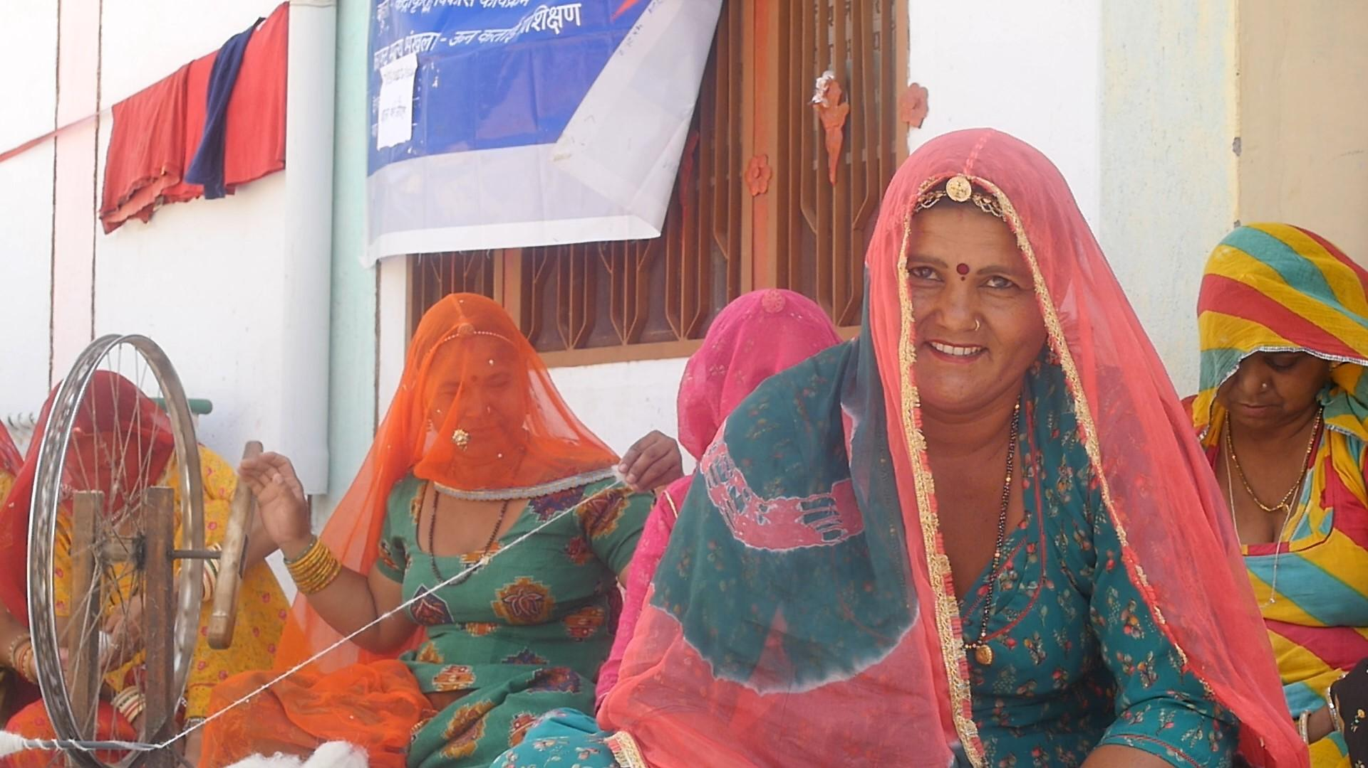
Rupa Devi dweller of Bala ka Gol village has an astonishing tale to tell about her wool spinning experience. The setup of the story is in one of the most arid regions of India where finding a good source of employment is very tough. The skill building programme under Bahula started by Urmul Seemant with the help of HDFC bank Parivartan has proved to be a boon for them.
Rupa devi met us in a community meeting organised by the Bahula Craft team. The female has a specially abled child and despite all the resistance from the society the proponent is beating all odds and providing the best of everything possible to her offspring for the past twenty years and still counting. The former had prior knowledge about spinning but this training further refined her skills and led to spinning of thinner yarn. The agenda served the community as whole with some twenty plus women gaining this beneficial skill. Now all the beneficiaries spin both thick and thin yarn which can be further used to produce cloth, socks, mats, rugs, carpets and much more.
Urmul Seemant has worked as an agent for removing the middlemen between these women and the market which further lead to income generation and better market linkage. Since there is the absence of middlemen, this leads to a nearly two-fold increase in their personal disposable income. The best part is that the majority of stakeholders are women who are fostering the idea of women empowerment right from the grassroots level. The people are seeing this as a remunerative opportunity and are willing to employ their children in the same.

- Name of the Beneficiaries: Bishanaram / Village: Barsalpur (District: Bikaner)
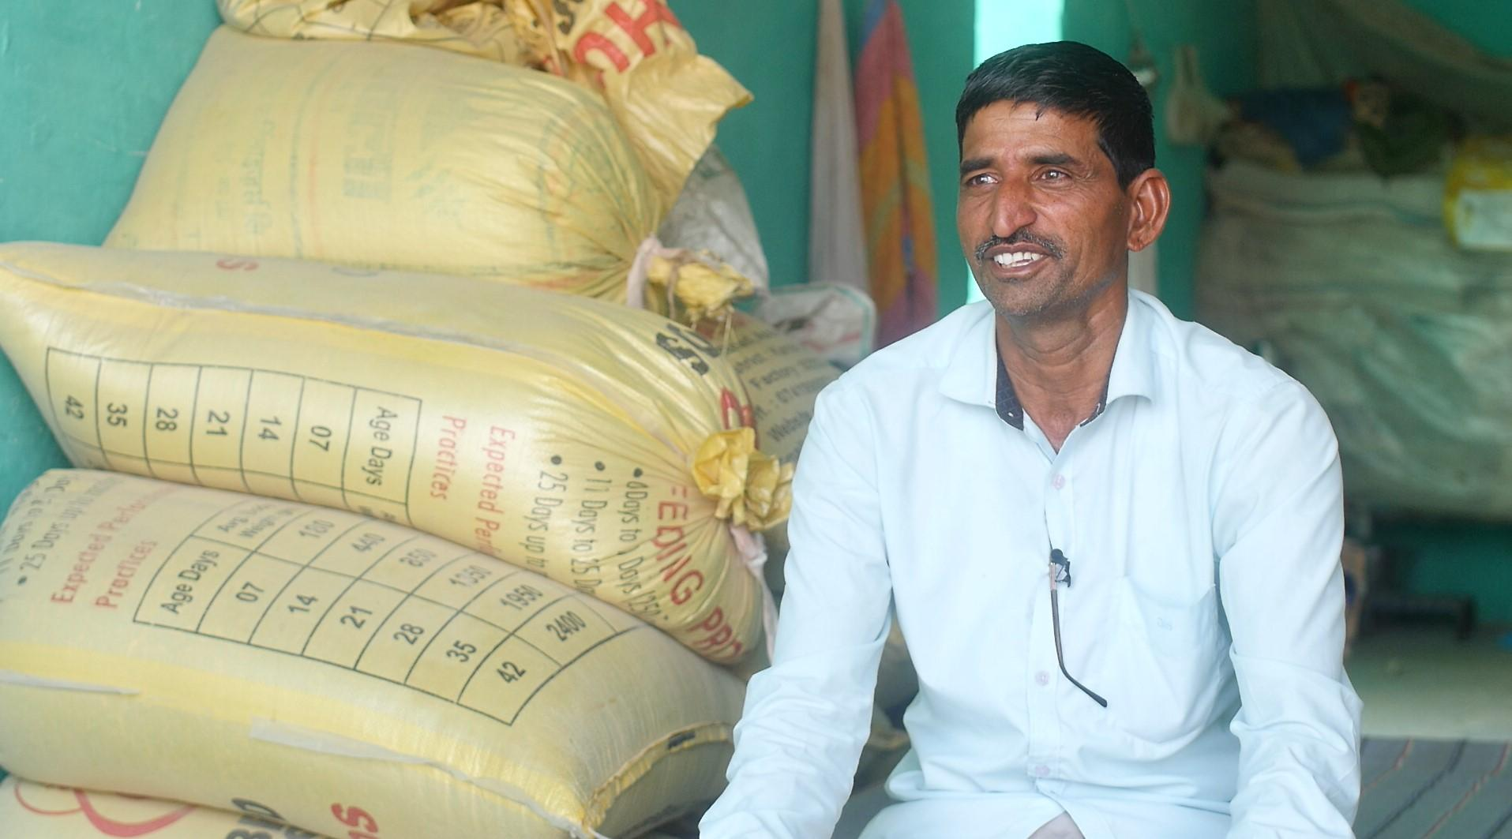
“As a farmer it is my humble request and advice to other farmers to indulge in black-wheat cropping. I also had doubts regarding it but it is only through awareness and proper dissemination of information that we can bring it into the mainstream food-grain market. I am sowing black wheat and will sow it in the future also.”
Bishnaram is a marginal farmer living in the village Barsalpur, situated near the Indo-Pak border. Their main source of income is agriculture. But living in a remote village, they had to sell their crops to middlemen, which affected their income.
The Bahula programme introduced the black wheat in this area for the first time. The first step towards the cultivation of black wheat proved to be a godsend step as it has the special ability to survive and thrive in the highly saline and alkaline arid regions of western Rajasthan. Another advantageous point of this crop is that the fodder produced by it is being highly liked by the cattle thus having a pragmatic impact on their health. 60 percent more iron concentration rich in antioxidants high in calcium is good for diabetic patients. The nutraceutical product is very effective in dealing with lifestyle disorders like diabetes, hypertension, blood pressure, inflammatory disease and obesity.
Bishnaram was worried about the sowing of black wheat to production, whether black wheat would be in this soil or not, and whether anyone would buy it or not. But even after these doubts, he grew black wheat organically and got good production. Later, the Bahula program bought back 5 quintals of black wheat at the rate of Rs 30 per kg. Due to this Bishanram and hundreds of farmers like him earned 30% more than their regular wheat sales leading to an income of INR 15000 per bigha per farmer.

